# Overview

This document contains the necessary information to use the Open Rocker Switch, a dual action accessible switch that can be activated by pressing either side of the rocker paddle. The design is based on the discontinued AbleNet Rocker Switch

Contents

Overview 1

Introduction 3

Features 3

Specifications 3

Compatibility 3

Usage 4

Initial Setup 4

Regular Use 4

Takedown / Storage 4

Care 4

Cleaning 4

Disposal 4

## Introduction

The Open Rocker Switch is an inexpensive 3D printable accessibility switch. The switch consists of two separate buttons that are activated by pressing on either side. This switch is comparable in size, activation force, and travel to the discontinued AbleNet Rocker Switch. The Open Rocker Switch has interchangeable button pieces and center divider pieces for users to customize and personalize their switch.

## Features

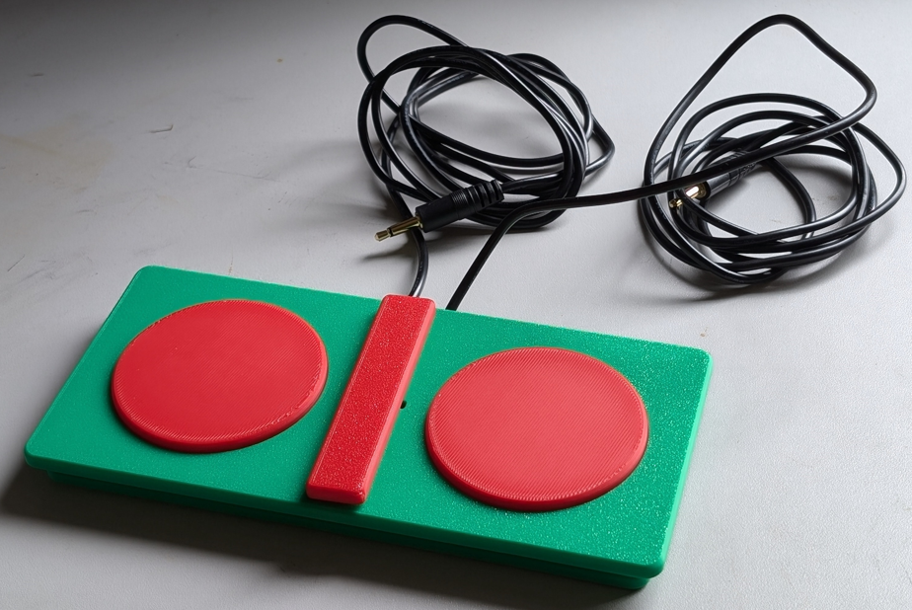

Button 1

Button 2

Mono Cable 2 222

Mono Cable 1 222

## Specifications

|  |  |
| --- | --- |
| Item | Open Rocker Switch |
| Size (Length x Width x Height) [mm] | 170x80x18mm |
| Mass [g] | 127g |
| Switch Travel [mm] | 1mm travel |
| Switch Force [g] | 134g |

## Compatibility

The Open Rocker Switch works with any device compatible with 3.5mm accessible switches. The device works best with devices that need two switches, such as switch scanning devices.

## Usage

### Initial Setup

Plug both of the mono cables from the rocker switch into the device to be controlled. The two cables come out different sides of the divider on the switch, the cable on the left side is connected to the switch on the left side and vice versa.

### Regular Use

When both switch inputs are connected to the device to be used, pressing one side of the rocker switch will activate the switch to that cable. Pressing the other side of the rocker switch will activate the other switch.

### Takedown / Storage

When not in use, the Open Playback Recorder should be stored in a cool place out of direct sunlight.

## Care

The Open Playback Recorder is made of 3D printed plastic. Exposure to high heat may cause warping and/or negatively affect function. Extended exposure to sunlight will also weaken the plastic on the device.

The Open Playback Recorder contains electronics and is not waterproof. If the device becomes wet, make sure it is off and do not use it until it has completely dried. It may help to open any electronic enclosures to speed up drying and ensure it has completely dried.

### Cleaning

The Open Playback Recorder can be wiped with a damp cloth.

## Disposal

PLA filament may be industrially compostable in your area. Check with your waste management company if PLA can be composted or must be thrown in the garbage.

Disassemble the Open Playback Recorder and separate out the recyclable and compostable components, and those that must be thrown out. Electronics and batteries should be disposed of following your local waste management guidelines.